Lecture 4 outline

DATA.

Video 1: The importance of data. 10 mins.

* We have seen in the previous lecture how simulation can be used, and the different ways that we can go about creating these simulations.
* We have created our own model, using hydraulic simulations.
* However, we also saw that these simulations are only as good as the data used to create them, and the appropriateness of each model type to the scenario.
* If we are going to investigate the movement of occupants of an elderly care home, it makes no sense to use data based on experiments that used students.
* This is both on the fundamental parameters, e.g. walking speed, reaction times, etc, but also on decision making, wayfinding, etc.
  + For example, many people don’t think twice about going downstairs. For an elderly person with arthritis, or low bone density, or any other of the large number of age-related degenerative diseases, this is not the case. Extreme care will be taken going downstairs, if that is done at all.
* Therefore the data used in these simulations is incredibly important. It is not constant- there are no constants in this field (yet!), and every figure used needs to be justified, and the error bounds surrounding them need to be quantified, before we can be certain of our answers.

In this section we’re going to talk about the importance of data, and how it affects our ability to simulate and predict movement. Over the previous lectures we have examined the ways we can model and create different simulations. We also saw that these simulations need to be calibrated, and can only ever model certain scenarios, depending on how they are built. Here we are going to discuss the specific data that we can use to calibrate these models.

For example, let’s say we want to analyse the design of an elderly care home, to ensure that an evacuation doesn’t result in blockages, or that all occupants can move around inside without being cramped. Now let’s look at exactly the same test case, but instead with a gym.

Obviously there will be a different demographic in the average gym than in the average care home, which results in completely different movement scenarios and typical occupant experiences.

To ensure that we simulate as accurately as possible, we need to measure and input some typical calibrative inputs. Without taking this into account, any simulation we produce will at best only bear a minimal resemblance to the real world, and at worst it will be actively counter-productive and dangerous.

Let’s have a look at the different types of input we might need to properly calibrate our models:

POPULATION CHARACTERISTICS:

* Agent specific data
  + Free walking speed. Usually given as a truncated distribution, there will be a minimum, maximum and mean speed. In simulations you might sample from this distribution and provide a value for each agent.
  + Maximum speed. As with above, people will have a maximum speed, defined by a distribution.
  + Staircase speed characteristics. Upstairs speed will be slower, but not linearly related to gradient. Downstairs speed might be higher, but this will be strongly dependent on multiple inputs, such as demographic and density.
  + Agent dimensions. Typical agent characteristic diameters might be ~1m, but that clearly increases
* Group specific data:
  + 1D density/speed relationships. This is the building block of characterising how people move in response to how close they are to others.
  + Crossflow relationships. How much does the agent/group speed change when considering flow in multiple directions?
* Other:
  + Wayfinding. This is slightly more difficult to measure and model, but an individual’s choice of route is very important when it comes to moving through a building with multiple paths. An example might be the choice of a queue at the canteen: do you go for the faster moving one, or the shorter one?

NON-OCCUPANT CHARACTERISTICS:

* + Building specific constraints.
    - Is the lighting good enough? This has a significant effect when considering the movement of people with limited sight.
    - Is the structure solid? This has a significant effect when considering motion of groups. See: Millennium Bridge, or (more tragically) the Hyatt Regency walkway.
    - Are the doors propped open? Flow through a building is significantly changed when occupants open and close doors.
    - Signage: are there clear signs on where to go? This will affect wayfinding.
  + Weather
    - Is it raining? Is it cold, or hot?
    - These will make significant changes to the movement of people, especially when we talk about extreme events.

These are appropriate inputs for almost any input, but there are far more that are scenario specific. In the next lecture we will talk about emergencies, and what kinds of data we need to properly model how people move in these situations.

Relevant links and papers:

PUT PAPERS HERE

Hyatt Regency link:

<https://en.wikipedia.org/wiki/Hyatt_Regency_walkway_collapse>

Video 2: Emergencies. 10 mins.

CHANGE THIS TO FOCUS MORE ON BUILDING BEHAVIOUR. EARTHQUAKES VS HURRICANES VS FIRES. HIGH RISE VS BUNGALOWS.

* As mentioned in the last video, data is perhaps the most important feature of these models. This poses a problem when it comes to the obvious benefit of pedestrian dynamics modelling: how do we get the data for emergencies?
* To begin with, let’s discuss the nature of emergencies, because they can result in very different behaviour.
* Natural: Floods, fires, hurricanes. Often all come at once. Climate change is going to screw the pooch on this one.
* Man-made: terrorist attacks, crashes, structural failure- often all come at once.
* Urbanisation is not helping with this, as higher density cities will need higher transport capacity for peak flows. Imagine, for a second, if a hurricane were to hit London. How would London respond? Would it evacuate the city? Is that even possible? A l

In the last video we talked about how we need specific data inputs for our simulations, otherwise they won’t represent real life at all (they won’t be ‘validated’).

In this section we look at a subset of examples where pedestrian dynamics can help, emergencies. As part of this we will discuss the nature of these emergencies, and examine exactly which variables we need as calibrative input for our models.

Question: What would you do if a tsunami was coming towards you?

* Get in a car and drive away?
* Run to the high ground?
* Stay in the house?
* Go for a swim?

Question: Would this change if this were a hurricane instead? What about a wildfire?

Final question:

Do you think that, in a densely populated city, there are enough people that would think the same thing as you, causing congestion and danger during your movements?

These types of questions are commonly considered on both the micro and macro scale. That is: movement through buildings during fires, and movement of city populations during large-scale emergencies are both regularly modelled using pedestrian dynamics models. However, these models need inputs on movement characteristics, which are often scenario specific.

Let’s look at the different scenarios:

Natural

* Floods
* Fires
* Hurricanes
* Etc.

Manmade

* Fires
* Terrorist attacks
* Car crashes
* Building structural failures.

What do we need to know to model these scenarios? We definitely need to be able to characterise the emergency itself, for example how long a building can burn before collapsing, how strong winds will be in a storm, how high the flood waters will get, or what type of terrorist attack we are considering. However, answering these questions is outside the scope of this course. Instead we are going to focus on how to model individual and group reactions to these types of emergencies, on a micro scale. In the next section we’ll talk briefly about how this applies on the macro-scale.

In lecture 2 we considered the different theories of group human behaviour in emergencies:

Panic Theory (now discredited)

Emergent Norm Theory

Social Affiliation Theory

Self-categorisation Theory

We can imagine how each of these three theories might apply. For instance, if you are in a building that is on fire, and you see all of your co-workers evacuating, you will probably do this as well (as happened WHEN). This can be explained by Emergent Norm Theory.

If instead, you are outside a building on fire, and a family member is inside, you might well head inside to try and help them (as happened WHEN). This can be explained by Social Affiliation Theory.

Finally, if you are on a tube during a terrorist attack, and you see that other commuters are hurt, you might stop to help them (as happened in 2005). This can be explained by Self-categorisation Theory.

However, one flaw here is that it is very difficult to use these theories to predict what will happen. We don’t have enough insight to know what makes people run away or hide. We don’t know when people will step in to stop an aggressive person, and we don’t know in which situations people will ignore instructions from a policeman.

This is a complex psychological question, but quantifying the proportions of people that stay or go, and what determines this, is an integral question. It might be dependent on the economic situation, or the mobility of this individual. It might be that people are more likely to stay if everybody nearby is staying.

This is where we need to obtain data to start informing our models (and our assumptions). In the next lectures we will first discuss the impact on the macro scale of these micro-scale considerations, and then we will discuss the different sources of data available.

A statistical analysis of the dynamics of household hurricane-evacuation decisions

Tawfiq Sarwar, Panagiotis Ch. Anastasopoulos, +2 authors Fred ManneringPublished 2018

DOI:10.1007/s11116-016-9722-6

Put in Beverly Hills Supper Club

Relevant links and papers:

PUT PAPERS HERE

Video 3: Emergency example: 2018 Wildfires in UK

* Follow the same approach as Arnab’s lecture.
* How does pedestrian dynamics help us in this scenario?

CHANGE TO WILDFIRE.

Here we can consider a very prevalent issue: wildfires.

Wildfires are dangerous, dynamic and uncontrolled emergencies, that often need the authorities to react very quickly.

Climate change will increase the number and scale of wildfires, leading to a huge requirement for more informed decision making.

In the Yorkshire, UK, 2018, there was a record-breaking set of wildfires that led to the declaration of a major incident

On 24th June 2018 fire broke out at Saddleworth Moor, and over the next few days covered more than 2000 acres and required the evacuation of ~150 people from their homes in Greater Manchester.

Changing winds meant that there was significant uncertainty over the direction of the fire,

There is a complex level of decision making when considering evacuating people. It costs money, takes time, and inconveniences people.

But there are uncertainties here: how long will it take? How much will it cost? So the question is: at what point do you take the decision to force an evacuation of these people?

Pedestrian dynamics can help by modelling exactly how long it will take to evacuate people. Or by assessing the best way of evacuating people. It can do this in real time (to an extent), and can accommodate different inputs (for example, whether people need specialist vehicles, or whether they can evacuate by themselves). They can then provide this information to the people that decide whether to evacuate a town, reducing the risk and uncertainty around this decision.

Further to this, there are also future implications. Autonomous vehicles will be able to pick up stranded people, with minimal risk.

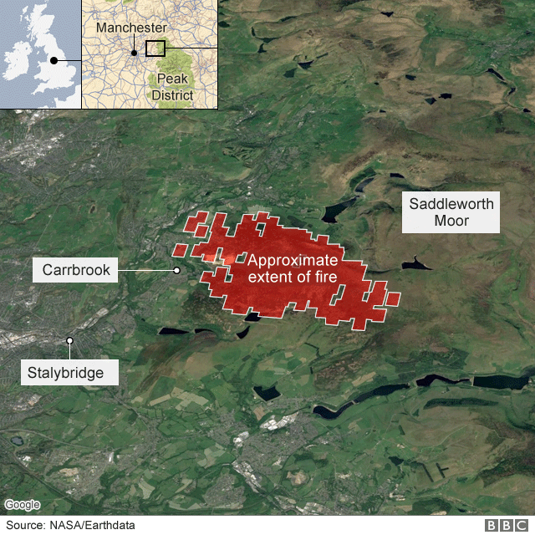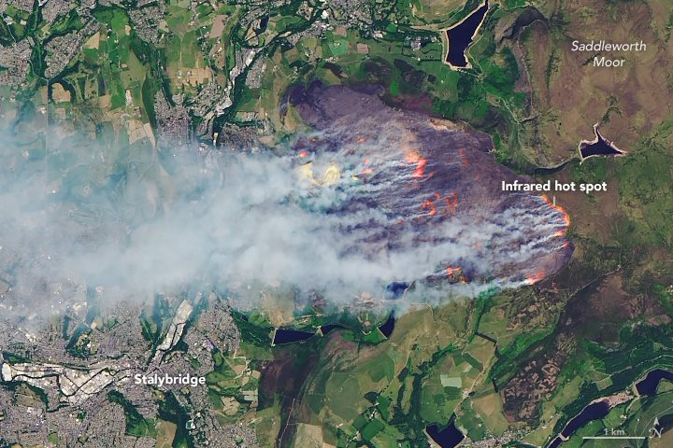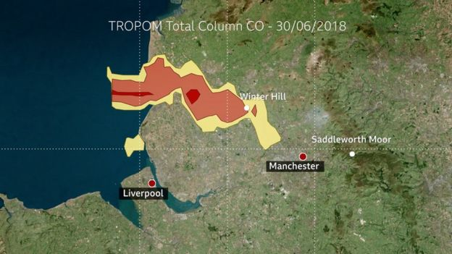

References:

Stephen Wong paper.

The west wing link:

<https://www.youtube.com/watch?v=QcASnEkmbvg>

Video 4: Data gathering vs data generating: Experiments. 10 mins.

* How do we create experiments to gather data on this?
  + Exploratory or specific?
  + Need to measure either a specific parameter, or
* Examples:
  + 1 dimensional flow. Gives fundamental diagrams.
  + Crossover flow. Can be used to measure crossflow.
  + Decision based experiments. Can be used for discrete decisions.
  + Hypothetical choice experiments. Can be used for discrete decisions.
  + Drills- can be used to validate software, practice evacuation methods, etc.
  + Animal experiments- can be used in stressful scenarios, but of limited validity?
  + Virtual reality- can be used to reproduce scenarios exactly, but struggles with validation.

So, let’s discuss the different methods of getting data through experiments.

* 1D flow

One of the simplest and most fundamental methods is the 1D flow experiment. This allows us to measure speed/density relationships in a 1-dimensional perspective.

PUT TOGETHER A .PPT SLIDE FOR THIS.

* 2D flow

Allows us to measure the impact of crossflows, but obviously more difficult to extract and parse out relevant information.

PUT TOGETHER A .PPT SLIDE FOR THIS

* Stated choice experiments

Allows us to measure predicted movements of people, based on internal heuristics.

* Drills

Allows us to approximate ecologically valid scenarios, while still being safe and (pretty much) controlled.

* Animal experiments

Possible to investigate much more stressful scenarios, with lower ethical barriers and more repetitions, for cheaper.

However, it obviously suffers from significant issues with ecological validity.

* Virtual reality

Possible to investigate any scenario, with exact measurements and low ethical barriers. Still expensive, and low levels of validation.

Relevant links and papers:

PUT PAPERS HERE

Video 5: Data gathering vs data generating: Real world sources. 10 mins.

* Benefits of all: ecologically valid.
* Drawbacks of all: not controlled or repeatable (to an extent). Impossible to infer real parameter values, but instead get indication of what to experiment with.
* CCTV or pre-installed video cameras.
  + Can be sensitive, especially in the case of emergencies like terrorism.
  + Need to extract data to usable form.
  + Often limited views, incomplete demographics etc.
* Large scale data (e.g. GPS pings)
  + Definitely sensitive, gives a macro-scale view only.
* Social media data (twitter, Facebook check-ins)
  + Publicly available, but of limited use?

In this section we’re going to talk about the different methods used to get data from real world scenarios.

1. CCTV footage.

Possible the best source of real world data, as you can get a large amount of data from it.

For example:

* Positional data- trajectories of people. The bread and butter data of micro-scale modelling.
* Group data- are people in groups? Are they families, friends, other?
* Qualitative action data: are they shopping, commuting, etc?
* Qualitative decision data: what options did the person observe, and which did they choose?

However, often takes a lot of pre-processing to get positional data, if it is possible at all. The qualitative data needs to be verified using inter-rater quality statistics.

No laboratory control- no way of checking the influence of specific variables using these datasets.

Often limited data density: e.g. no demographics,

Often sensitive: e.g. in terrorist attacks.

1. Large scale data,

* GPS pings, for example offer limited accuracy, limited time resolution,
* These are private. People don’t want their movements spread around.

SHOW THE TABLEAU EXAMPLE.

1. Social media data

* Not private.
* Not reliable (fake posts)
* Not relevant (often completely useless data).

Relevant links and papers:

PUT PAPERS HERE

Workshop:

How would we investigate the pedestrian dynamics of a terrorist attack?

HOW DOES THIS HELP THEM IN THEIR EXAMS?

* Qualitative